**PORTFOLIO PROJECT**

Submitted by

**Aswath Soorya PV**

**Reg. No: 1P25CS002**

In partial fulfilment of the requirement for the award of the Degree of

### Master of Science in Computer Science

### Bharathiar University, Coimbatore.

Under the Internal Supervision of

# Dr. P. V. Ravindranath M.Sc., Ph.D.,

**Assistant Professor**

**School of Computer Studies-PG**



### School of Computer Studies-PG,

**RVS College of Arts and Science (Autonomous),**

### Sulur, Coimbatore – 641 402

**October- 2025**

### RVS COLLEGE OF ARTS AND SCIENCE (AUTONOMOUS)

**AFFILIATED TO BHARATHIAR UNIVERSITY**

**NAAC Re-accredited & ISO 9000:2008 Certified SULUR, COIMBATORE-641402.**

**Master of Science in Computer Science**



**October 2024**

**Register Number – 1P25CS002**

Certified bonafide original record of work done by **ASWATH SOORYA PV**

Submitted for the project Evaluation and Viva voice held on**………………….**

### Internal Supervisor HOD

### Internal Examiner External Examiner

# 

# Certificates

# 

# Certificate

This is to certify that the project work entitled **PORTFOLIO**, submitted to the School of Computer Studies(PG), RVS College of Arts and Science in partial fulfillment of the requirements for the award of the Degree of Master of Science in Computer Science is a record of original project work done by **ASWATH SOORYA PV** during the period July 2024- October 2024 of her study in the **Master of Science in Computer Science, RVS College of Arts and Science**, under my internal supervision and the project work has not formed the basis for the award of any Degree/Diploma/Associateship/Fellowship or other similar title to any candidate of any University.

Internal Supervisor

# 

# Declaration

## 

## **Declaration**

I, **ASWATH SOORYA PV**, hereby declare that the project work, entitled **PORTFOLIO**, submitted to the School of Computer Studies(PG), RVS College of Arts and Science, in partial fulfillment of the requirements for the award of the Degree of Master of Science in Computer Science is a record of original project work done by me during the period July 2024–October 2024 under the internal supervision of **Dr.P.V.Ravindranath, M.Sc. CS, Ph.D.,** Assistant Professor, School of Computer Studies, RVS College of Arts and Science, and it has not formed the basis for the award of any Degree/ Diploma/Associateship/Fellowship or other similar title to any candidate of any University.

# Signature of the Candidate

# 

Acknowledgement

## **Acknowledgement**

If words are considered as symbols of approval and tokens of acknowledgement, then the

words play the heralding role of expressing my gratitude to all who have helped me directly or indirectly during my project work.

I will be ever graceful and thankful to **Dr. T. Sivakumar, M.Sc., M.Phil., Ph.D., Principal**, RVS College of Arts and Science for allowing me to do my project with his moral support.

It gives me immense pleasure to take this opportunity to express my gratitude and thanks **Dr. P. Navaneetham, M.Sc., M.Phil., Ph.D., Associate Professor & Director Administration, School of Computer Studies**, RVS College of Arts and Science for his continuous encouragement and blessings. First and foremost, my utmost gratitude to **Dr.S.Yamini, M.Sc., M.Phil., Ph.D., Associate Professor & Director Academics, School of Computer Studies**, RVS College of Arts and Science for her ardent support and noble patronage.

I proudly feel graceful to **Dr.D.Maheswari, M.Sc., M.Phil., Ph.D**., **Associate Professor, Head & Research Coordinator, M.Sc. Computer Science, School of Computer Studies(PG),** RVS College of Arts and Science for providing me this opportunity and extending a constant monitoring throughout the course of the project.

With my gratitude I would like to acknowledge the immense encouragement given to me

by **Dr. P.V.Ravindranath, M.Sc. CS., Ph.D., Assistant Professor, School of Computer Studies (PG),** RVS College of Arts and Science who is my internal guide, for her valid suggestions, and counsel, and ever willing to extend help. I am deeply obliged to his for the encouragement and without him the project work would not have been successful.

**RAGUL M**

**PORTFOLIO PROJECT**

# 

# Abstract

## **Abstract**

An abstract of a portfolio typically provides a concise overview of the contents and key highlights of the portfolio. It serves as a summary that offers a glimpse into the scope and purpose of the portfolio. The abstract may include a brief description of the portfolio's main objectives, the types of assets or projects included, the methodologies used, and the overall outcomes or achievements. Additionally, it might highlight the significance of the portfolio in relation to the broader context or industry, showcasing the relevance and impact of the work. The abstract aims to capture the essence of the portfolio, enabling readers to quickly grasp its essence and potential significance

# 

# Content

**CONTENT**

# PORTFOLIO PROJECT

Chapter 1: 1

Video Introduction

1.1. YouTube Video

Chapter 2: 2

Website Bio Score

* 1. Minimum 50 words (Include photo)
  2. Contact Information (LinkedIn, GitHub, Email, Etc.)

# Chapter 3: 8

Pages & Navigation

* 1. Landing Page

3.2. Project Page

3.3. Navigation Bar

# Chapter 4: 19

Styles Score

* 1. Styles (Font Color Images)
  2. Styles Link (Link in Blue color & Underline Navigation)
  3. Use of Grid Layout

# Chapter 5: 24

Website Include the Following Information

* 1. Project Links to GitHub
  2. Project Description (1-5 sentences per projects)

# Chapter 6: 26

Project README

* 1. Title Description (Min 20 words)
  2. How to Run Project
  3. Future improvements of projects

# Chapter 7: 27

File Structure

7.1. GitHub File Structure

PORTFOLIO PROJECT

# CHAPTER 1

## **VIDEO INTRODUCTION**

**1.1 YouTube Video Introduction**

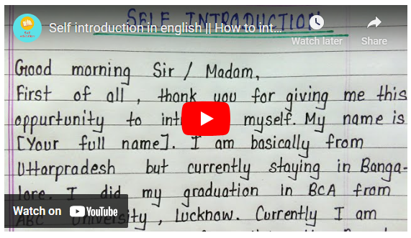

## Source code:

**HTML:**

## <iframe width="560" height="315" src="https://www.youtube.com/embed/r29CFLctWIY?si=KpQitpIRKj0KZZoA" title="YouTube video player" frameborder="0" allow="accelerometer; autoplay; clipboard-write; encrypted-media; gyroscope; picture-in-picture; web-share" referrerpolicy="strict-origin-when-cross-origin" allowfullscreen></iframe>

## **CSS**:

.selfintro{

  border-radius : 20px;

  border : 2px solid #142b47;

  animation : self 1s ease-in-out;

}

**CHAPTER 2**

**WEBSITE BIO SCORE**

**2.1About Me and Download CV**

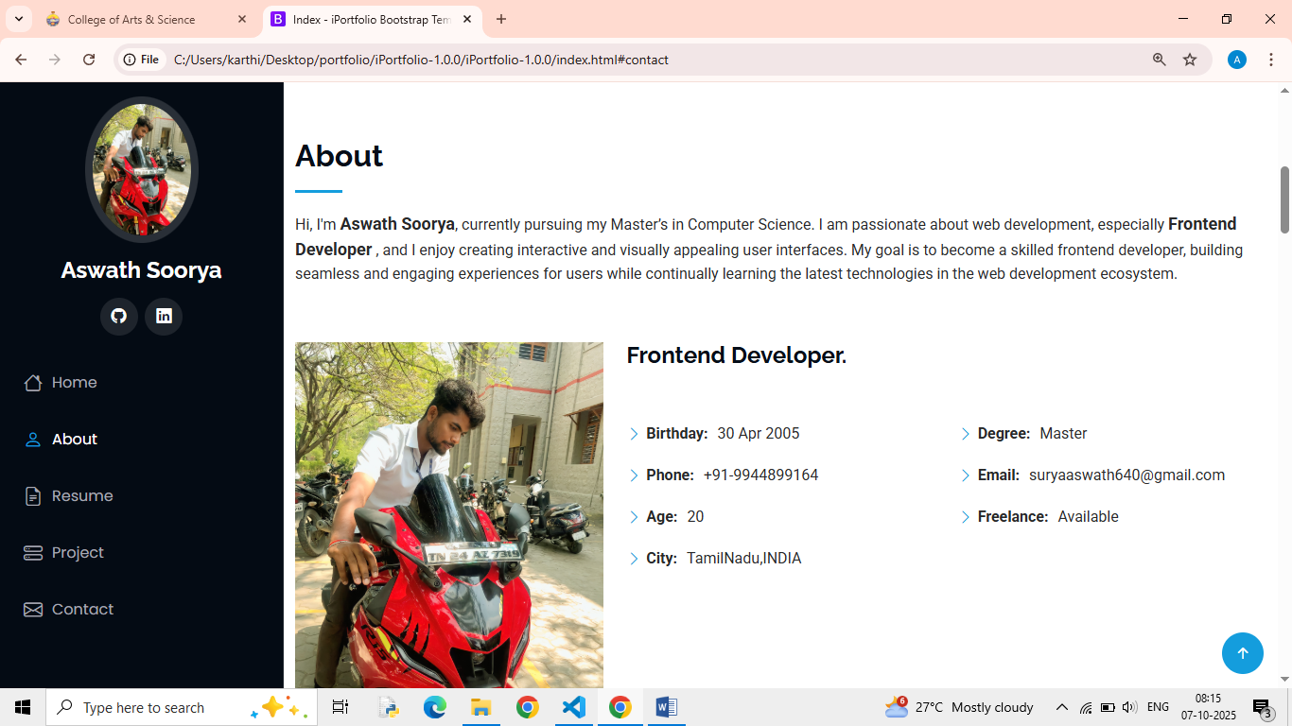

Figure- 2.1.1

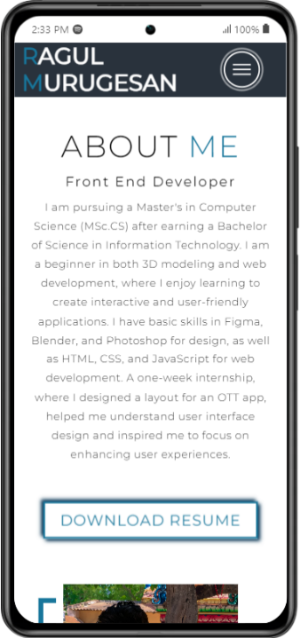

Figure- 2.1.2

**Description:**

In this page, there is an Image of mine, paragraph about me. So that the details of my biodata have been given. This HTML code creates an "About" section for a personal portfolio website. It consists of two main parts: the left column displaying an image and the right column containing text. The text introduces the person as a front-end developer pursuing a Master's in Computer Science, with skills in 3D modeling and web development. It mentions experience with tools like Figma, Blender, and Photoshop, as well as HTML, CSS, and JavaScript. The code also includes a link to download the resume via a call-to-action (CTA) button.

## **Source code:**

**HTML**

 <!-- About Section -->

  <section id="about">

    <div class="about container">

      <div class="col-left">

        <div class="about-img">

          <img src="./img/Ragul-Portrait.jpg" alt="img">

        </div>

      </div>

      <div class="col-right">

        <h1 class="section-title">About <span>me</span></h1>

        <h2>Front End Developer</h2>

        <p>

          I am pursuing a Master's in Computer Science (MSc.CS) after earning a Bachelor of Science in Information Technology.

          I am a beginner in both 3D modeling and web development, where I enjoy learning to create interactive and user-friendly applications.

      </div>

    </div>

  </section>

  <!-- End About Section -->

## **CSS:**

/* About Section */

#about .about {

    flex-direction: column-reverse;

    text-align: center;

    max-width: 1200px;

#about .col-left .about-img::after {

    content: '';

    position: absolute;

    left: -33px;

    top: 19px;

    height: 98%;

    width: 98%;

    border: 7px solid #18769b;

    z-index: -1;

}

**CONTACT INFORMATION**

**2.3. Contact Page**

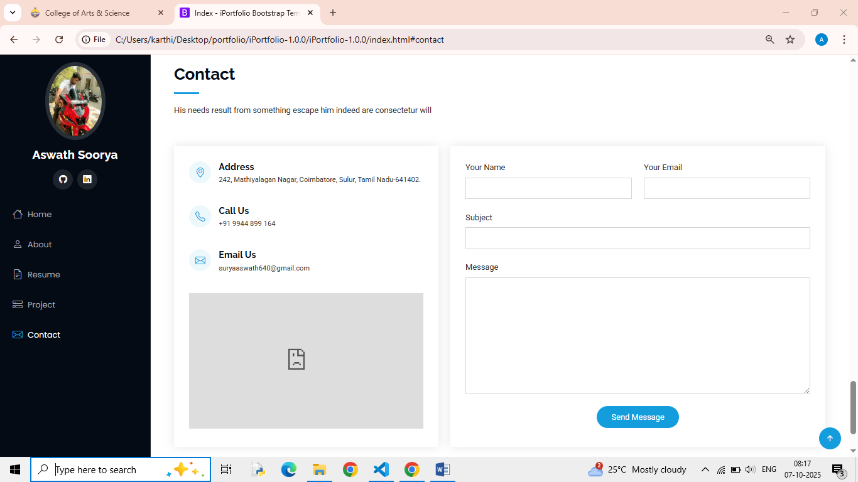

Figure- 2.3.1

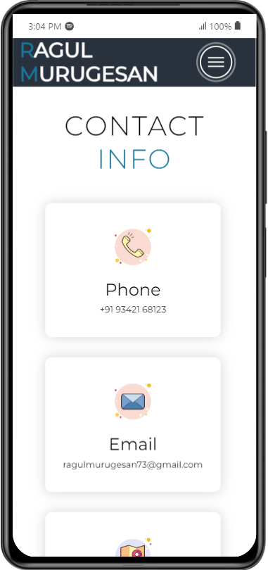

Figure- 2.3.2

**Description:**

The Above figure 2.3.1. The Contact section presents essential information, including a phone number, email address, and physical address, each accompanied by relevant icons for easy identification. This layout allows visitors to quickly access contact details.

**HTML:**

<!-- Contact Section -->

  <section id="contact">

    <div class="contact container">

      <div>

        <h1 class="section-title">Contact <span>info</span></h1>

      </div>

      <div class="contact-items">

        <div class="contact-item">

        <div class="contact-item">

          <div class="icon"><img src="https://img.icons8.com/bubbles/100/000000/map-marker.png" /></div>

          <div class="contact-info">

            <h1>Address</h1>

            <h2>Keeranur, Pudukkotai,  Tamil Nadu, India</h2>

      </div>

    </div>

  </section>

  <!-- End Contact Section -->

**CSS:**

/* contact  */

    #contact .contact {

        flex-direction: column;

        padding: 100px 0;

        align-items: center;

        justify-content: center;

        min-width: 20vh;

    }

    #contact .contact-items {

        width: 100%;

        display: flex;

        flex-direction: row;

        justify-content: space-evenly;

        margin: 0;

    }

    #contact .contact-item .icon {

        height: 100px;

        width: 100px;

    }

    #contact .contact-item .icon img {

        object-fit: contain;

    }

    #contact .contact-item .contact-info {

        width: 100%;

        text-align: left;

        padding-left: 20px;

    }

    /* End contact  */

**CHAPTER 3**

**PAGES & NAVIGATION**

**3.1 Landing page**

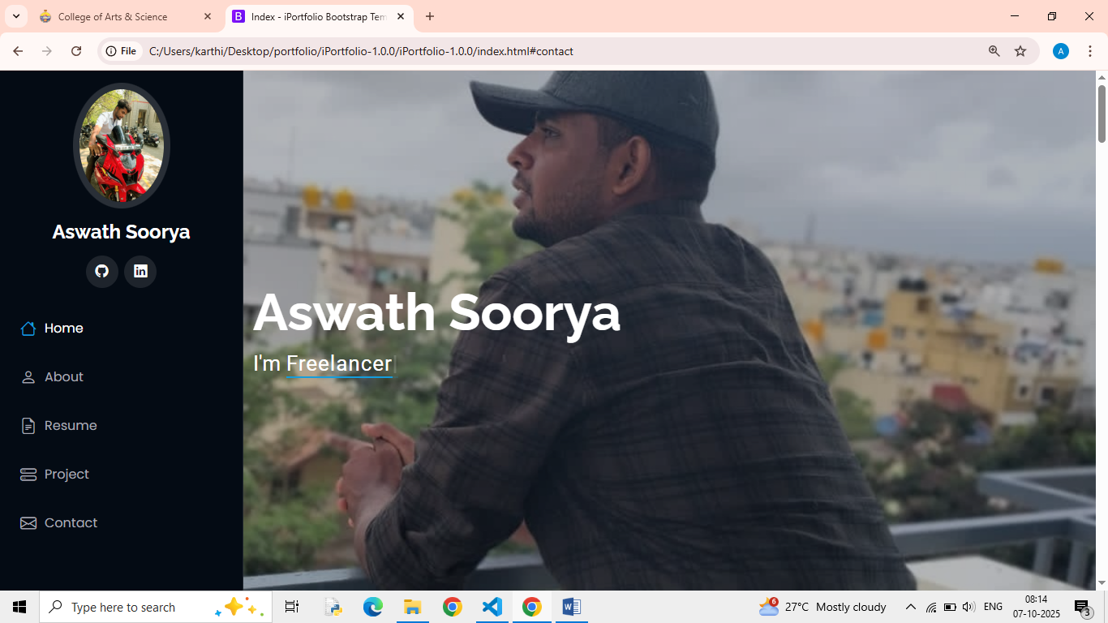

Figure- 3.1.1

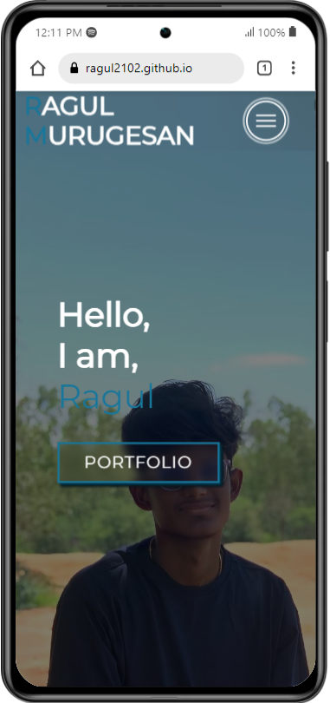

Figure- 3.1.2

## **Description:**

The above figure - 3.1.1 are the screenshot of Homepage in a desktop view.The landing page features a stylish header with navigation links to Home, Interests, Projects, About, and Contact. The hero section warmly greets visitors, inviting them to explore the portfolio through a prominent call-to-action button, effectively showcasing skills and projects.

**HTML:**

 <!-- Hero Section  -->

  <section id="hero">

    <div class="hero container">      <div>

        <h1>Hello, <span></span></h1>

        <h1>I am,<span></span></h1>

        <h1>Ragul<span></span></h1>

        <a href="#projects" type="button" class="cta">Portfolio</a>

      </div>

    </div>

  </section>

  <!-- End Hero Section  -->

## **CSS:**

/* Hero Section */

#hero {

    background-image: url(./img/Ragul-Landscape.jpg);

    background-size: cover;

    position: relative;

    z-index: 1;

}

}

}

#hero h1:nth-child(3) {

    animation: text_reveal_name 0.5s ease forwards;

    animation-delay: 3s;

}

#hero h1 span {

    position: absolute;

    top: 0;

    left: 0;

    height: 100%;

    width: 0;

    background-color: #005677

    animation-delay: 0.5s;

}

#hero h1:nth-child(1) span {

    animation-delay: 0.5s;

}

#hero h1:nth-child(2) span {

    animation-delay: 1.5s;

}

#hero h1:nth-child(3) span {

    animation-delay: 2.5s;

}

/* End Hero Section */

**3.2 Project Page**

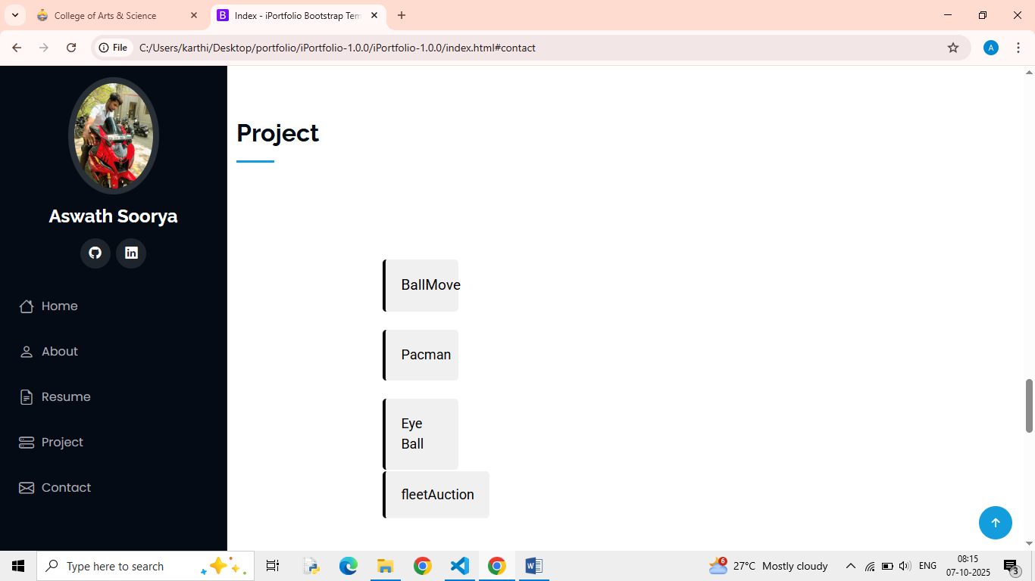

Figure- 3.2.1

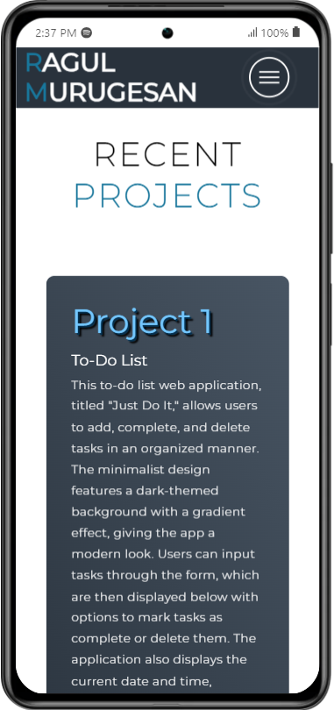

**Description:**

The above figures-3.2.1 is the screenshot of project page in a desktop view. The Projects section highlights key works, including a minimalist to-do list web application and a low-poly 3D model of a traditional "Tea Kadai," showcasing skills in web development and 3D modeling.

## **Source Code**

**HTML:**

<!-- Projects Section -->

  <section id="projects">

    <div class="projects container">

      <div class="projects-header">

        <h1 class="section-title">Recent <span>Projects</span></h1>

      </div>

      <div class="all-projects">

        <div class="project-item">

          <div class="project-info">

            <h1>Project 1</h1>

            <h2>To-Do List</h2>

          </div>

          <div class="project-img">

            <img src="./img/Tea Kadai.png" alt="img">

          </div>

        </div>

      </div>

    </div>

  </section>

  <!-- End Projects Section -->

**CSS:**

/* Projects section */

#projects .projects {

    flex-direction: column;

    max-width: 1200px;

    margin: 0 auto;

    padding: 100px 0;

}

#projects .projects-header h1 {

    margin-bottom: 50px;

}

#projects .all-projects {

    display: flex;

    align-items: center;

    justify-content: center;

    flex-direction: column;

}

}

#projects .project-img img {

    transition: 0.3s ease transform;

}

#projects .project-item:hover .project-img img {

    transform: scale(1.1);

}

/* End Projects section */

**3.3 Navigation Bar**

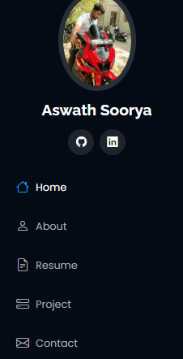

Figure- 3.3.1

## **Description:**

The figure-3.3.1 are the samples of navigation bar in both desktop View. The header includes a navigation bar with links to Home, Interests, Projects, About, and Contact, featuring a prominent brand name and a mobile-friendly hamburger menu.

**HTML:**

<!-- Header -->

  <section id="header">

    <div class="header container">

      <div class="nav-bar">

        <div class="brand">

          <a href="#hero">

            <h1><span>R</span>agul <span>M</span>urugesan</h1>

          </a>

        </div>

        <div class="nav-list">

          <div class="hamburger">

            <div class="bar"></div>

          </div>

          <ul>

            <li><a href="#hero" data-after="Home">Home</a></li>

            <li><a href="#services" data-after="Interest">Interest</a></li>

            <li><a href="#projects" data-after="Projects">Projects</a></li>

            <li><a href="#about" data-after="About">About</a></li>

            <li><a href="#contact" data-after="Contact">Contact</a></li>

          </ul>

        </div>

      </div>

    </div>

  </section>

  <!-- End Header -->

**CSS:**

@import 'https://fonts.googleapis.com/css?family=Montserrat:300, 400, 700&display=swap';

* {

    padding: 0;

    margin: 0;

    box-sizing: border-box;

}

html {

    font-size: 10px;

    font-family: 'Montserrat', sans-serif;

    scroll-behavior: smooth;

}

a {

    text-decoration: none;

}

.container {

    min-height: 100vh;

    width: 100%;

    display: flex;

    align-items: center;

    justify-content: center;

}

.brand h1 {

    font-size: 3rem;

    text-transform: uppercase;

    color: white;

}

.brand h1 span {

    color: #18769b;

}

/* End Header section */

**CHAPTER 4**

## **STYLES SCORE**

* 1. **Font link**

@import 'https://fonts.googleapis.com/css?family=Montserrat:300, 400, 700&display=swap';

## **Style links**

<link rel="stylesheet" href="style.css"

**#header {**

**position: fixed;**

**z-index: 1000;**

**left: 0;**

**top: 0;**

**width: 100vw;**

**height: auto;**

**}**

**#header .header {**

**min-height: 8vh;**

**background-color: #00000057;**

**backdrop-filter: blur(50px);**

**transition: 0.3s ease background-color;**

**#header .nav-list ul {**

**list-style: none;**

**position: absolute;**

**background-color: rgb(31, 30, 30);**

**width: 100vw;**

**height: 100vh;**

**left: 100%;**

**top: 0;**

**display: flex;**

**flex-direction: column;**

**}**

**#header .hamburger .bar::after {**

**top: 8px;**

**}**

**#header .hamburger .bar::before {**

**bottom: 8px;**

**bottom: 0;**

**}**

**CHAPTER 5**

## **Website include the following Information**

**5.1 project links to GitHub:**

# Project-1

# 

# https://ragul2102.github.io/ToDo-List/

**Title: ToDo List**

* **Project Description:**

**Just Do It**: A minimalist to-do list app for managing tasks, built with HTML, CSS, and JavaScript.

# PROJECT 2

https://ragul2102.github.io/Blender-Models/Tea%20Kadai.png

**Title: Tea Kadai**

* **Project Description:**

**Tea Kadai 3D Model**: A low-poly 3D model of a traditional tea shop, featuring seating, potted plants, and a teacup on the roof, created in Blender to evoke a charming atmosphere.

# CHAPTER 6

**Project README (Description, steps to run, future improvement)**

**PROJECT 1**

**ToDo List**

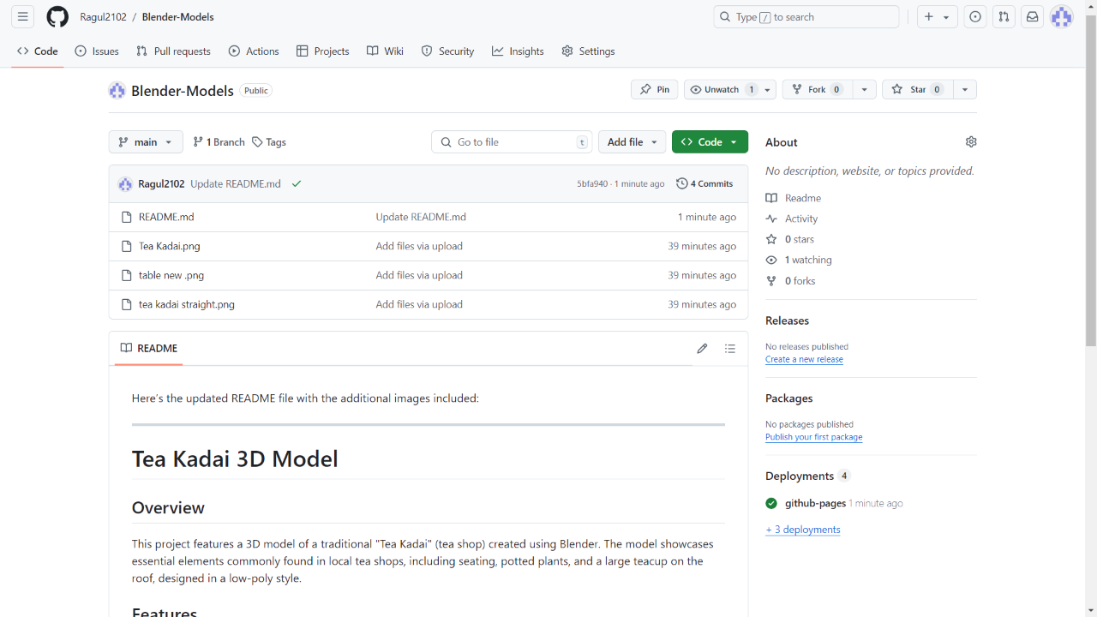

Figure 6.1.1

**PROJECT 2**

**Blender Model**

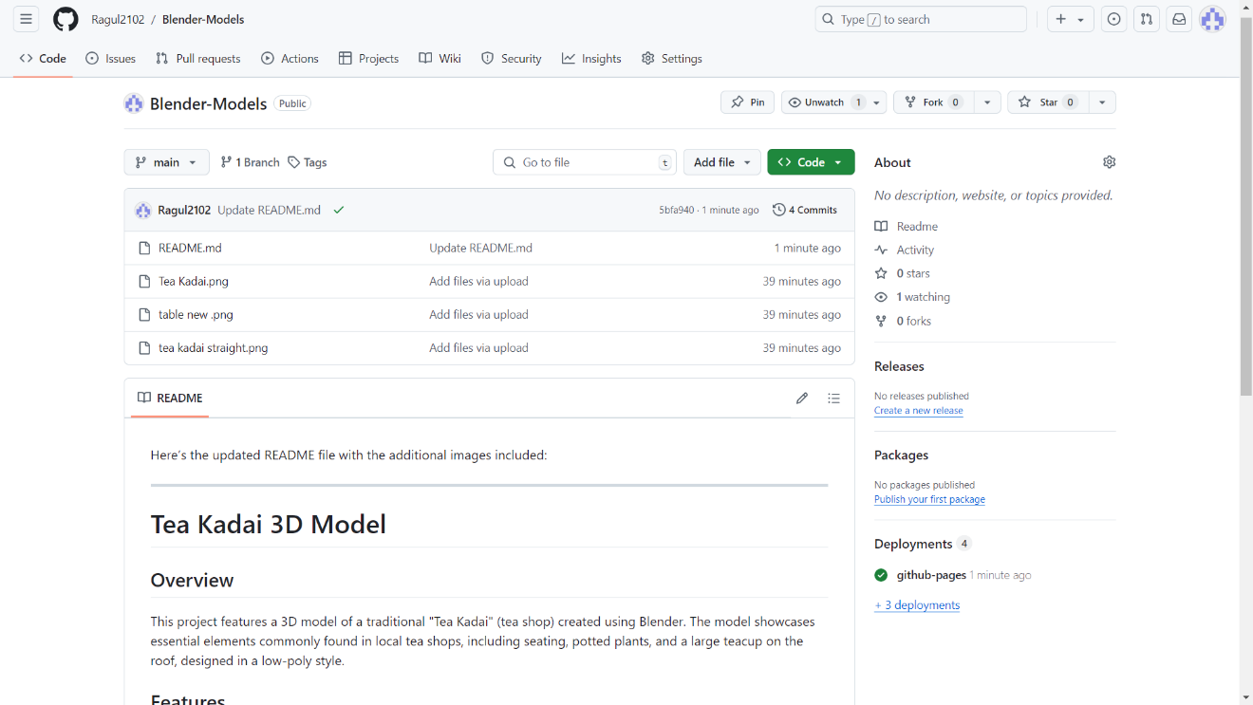

Figure 6.1.2

**Chapter-7**

**File structure**

**7.1 GitHub file structure Task- 1 File Structure:**



Figure 7.1.1

**Task- 2 file structure:**

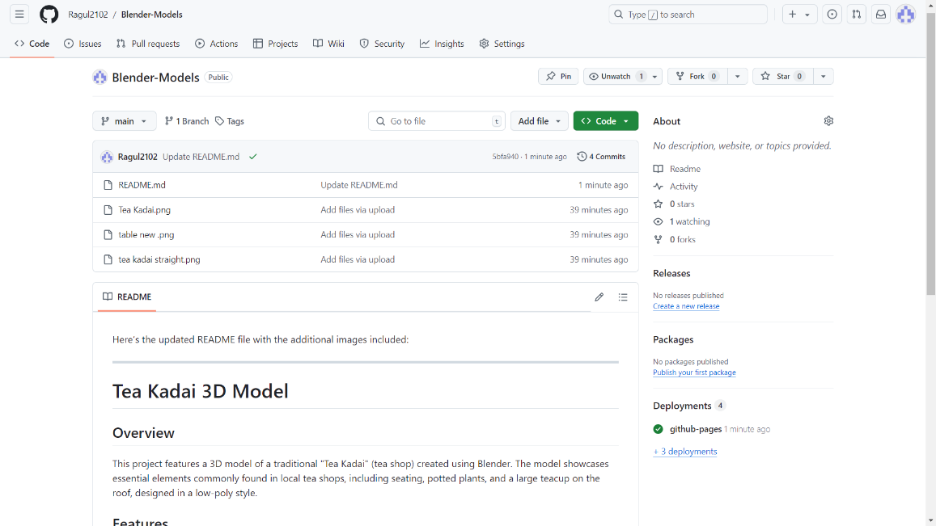

Figure 7.1.2

**Description:**

The above fig-7.1.1, fig-7.1.2, are the screenshots of project GitHub file structure in desktop view